<https://www.balluff.com/de-de/products/BES0068?pf=F01102&pm=BESMStandard>

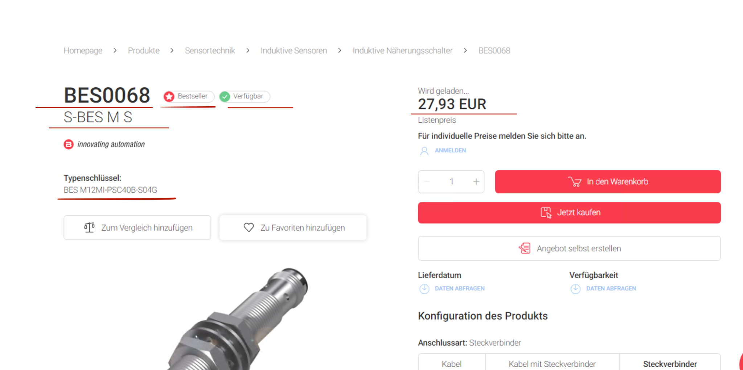

[https://www.balluff.com/de-de/products/BSP00YN?attrs[cal_pm_range_pressure_max][min]=0.05&attrs[cal_pm_range_pressure_max][max]=0.05&pm=BSP+with+Display+(Standard)&pf=F01007](https://www.balluff.com/de-de/products/BSP00YN?attrs%5Bcal_pm_range_pressure_max%5D%5Bmin%5D=0.05&attrs%5Bcal_pm_range_pressure_max%5D%5Bmax%5D=0.05&pm=BSP+with+Display+(Standard)&pf=F01007)

